Code:
def bresenham_line(x1, y1, x2, y2):
# Calculate dx and dy
dx = x2 - x1
dy = y2 - y1
# Initial point
x, y = x1, y1
# Decision parameter
p = 2 * dy - dx
# List to store points
points = [(x, y)]
# Loop through all x values
for i in range(dx):
if p < 0:
x += 1
p = p + 2 * dy
else:
x += 1
y += 1
p = p + 2 * (dy - dx)
points.append((x, y))
return points
# Main program to draw a line from (2, 2) to (8, 5)
line_points = bresenham_line(2, 2, 8, 5)
# Print points
print("Line points:")
for p in line_points:
print(p)

Output:
Line points:
(2, 2)
(3, 3)
(4, 3)
(5, 4)
(6, 4)
(7, 5)
(8, 5)
Note: Now,you can plot above points using Matplotlib
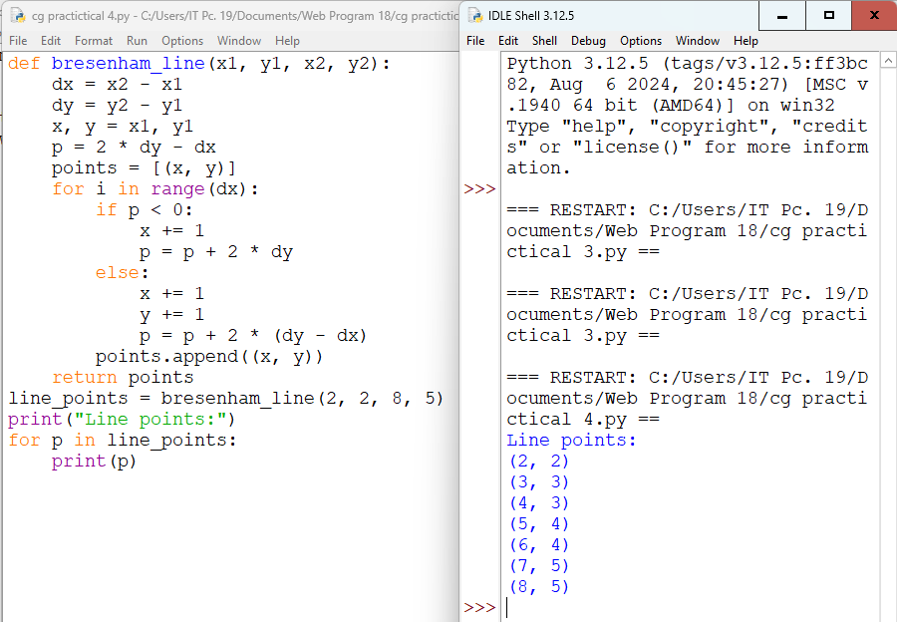
Code to plot above point using Matplotlib:
import matplotlib.pyplot as plt
# Points
x = [2,3,4,5,6,7,8]
y = [2,3,3,4,4,5,5]

# Draw line connecting points
plt.plot(x, y)
# Display the plot
plt.show()

output:
